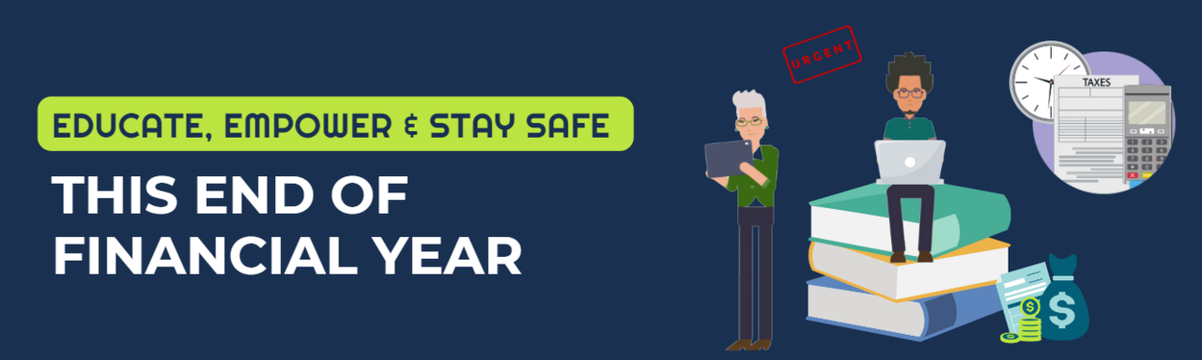
As we approach the End Of Financial Year (EOFY) and beyond, it's crucial for us to reinforce the importance of cyber safety. During this time, cyber criminals ramp up their activities, often disguising their attempts as tax-related communications. These scams can result in the loss of sensitive data, compromise our systems, and can significantly impact our organisation, not to mention your own finances.
I would like to draw your attention to the EOFY Tip Sheet that our partners Phriendly Phishing have prepared. These sheets provide an overview of the common scams you might encounter during tax time and offer practical advice on how to protect yourself and our business from cyber threats. Please make sure to read them carefully and apply the tips in your day-to-day.
Your safety is our top priority. By staying vigilant and following the guidelines provided in the EOFY Tip Sheet here, we can all contribute to our organisation's cybersecurity. You can also ‘Spot the Phish’ in this interactive animation.

If you have any questions or concerns, don't hesitate to reply to this email.
Remember, it's better to be safe than sorry.

